PUPIL SUPPORT FILE
School Support Plus

Name of Pupil

Date of Birth

School

Date File Opened

Date File Closed

A Continuum of Support

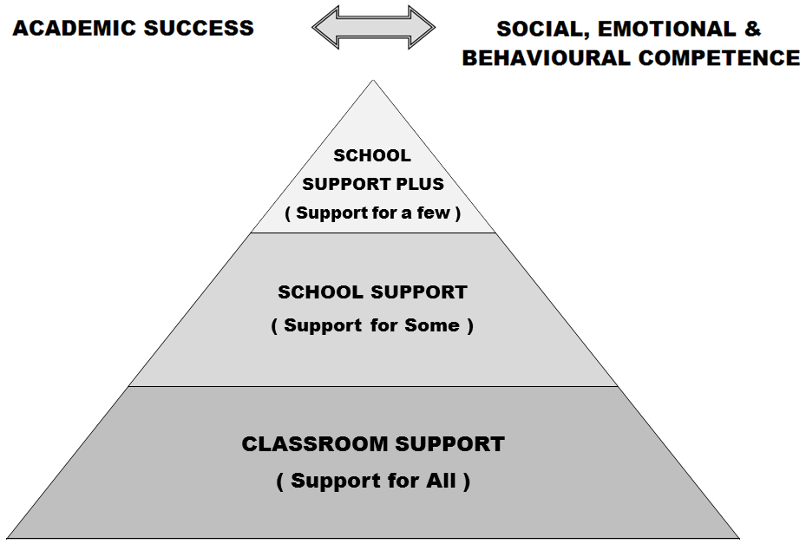

Developing a pupil support plan is the outcome of a problem solving process, involving school staff, parent(s)/ guardian(s) and the pupil. We start by identifying concerns, we gather information, we put together a plan and we review it.
Pupil Support File, Log of Actions / Meetings

Date: Actions:

Support Checklist

Name: | Age: | Class:
General Information: | Date Checked : | Comments:
- Parents/ Guardians Consulted
- Information from previous school/preschool gathered
- Hearing
- Vision
- Medical Needs
- Basic Needs Checklist completed
- Assessment of learning- screening
- Observation of learning style/approach to learning
- Observation of behaviour
- Interview with pupil
- Classroom work differentiated?
- Learning environment adapted?
- Yard/school environments adapted?
- Informal or formal consultation/advice with outside professionals?
- Advice given by learning support/resource teacher or other school staff?
- Other interventions put in place in school?
Action Needed:
Helpful references: SEN: A Continuum of Support: Resource Pack for Teachers, pp. 13-16, 18 to 20; BESD: A Continuum of Support, p 7; A Continuum of Support for Post-Primary Schools, Resource Pack for Teachers, pp32-36; Pupil Support Teams in Post-Primary Schools, pp20

Basic Needs Checklist

Physiological needs e.g. does the child have adequate food, warmth, housing etc?

Safety needs e.g. does the child need physical or psychological protection?

Belonging needs e.g. does the pupil have close family and friends, feel part of his / her class.

Esteem needs: e.g. does the child receive respect, positive feedback from others and respect others and self?

Possible actions suggested to the teacher on the basis of the questions above:

Assessment Record
Junior Infants | Senior Infants | First Class
PSAK Initial Assessment  _____________ | PSAK Initial Assessment  _____________ | PSAK Initial Assessment  _____________
PSAK Level 1 Assessment  _____________ | PSAK Level 1 Assessment  _____________ | PSAK Level 1 Assessment  _____________
Letter Sounds  ______ / 26 | DTEN  Pre-Number ______% | Micra T  STEN __________  %ile ___________
Letter Formation  ______ / 26 | DTEN  Numeration ______% | Sigma T  STEN __________  % ile ___________
BIC Language Skills  ______ / 20 | DTEN  Addition & Subtraction  ______% | BAS  Reading Age  _______ Y _______M
BIC Memory Skills  ______ / 12 | DTEN - Total (Cut-Off 17)  _______
BIC Number Skills  ______ / 9 | MIST - Listening Skills  ________ / 15
BIC Motor Skills  ______ / 11 | MIST - Letter Sounds  ________ / 26
BIC Total  ______ / 60 | MIST - Written Vocabulary  ________
MIST - 3 Phoneme Words
________ / 15
MIST - Dictation
________ / 36
BAS - Reading Age
_______ Y _______M

Outside Professionals/Agencies
Agency (SLT, OT etc) | Name of Professional | Date of Report | Diagnosis
sUPPORT PLAN Classroom Support
School Support (Support for Some)
School Support Plus (Support for A Few)

Pupil’s Name: |  |  |  | Age in Sept:
Teachers: | Class Teacher:  LSRT(s): |  |  | Class/Year:
Start Date of Plan: |  |  | Review Date of Plan:
Pupil’s Strengths and Interests:

Agreed Priority Concerns:
1.
2.
3.
4.
Priority Concerns and were agreed between Parents and Teachers, taking cognisance of assessment results, the child’s strengths and challenges, recommendations from outside agencies (if any)
Targets for the Pupil:
Parents, class teachers and support teachers have agreed to work on the following targets, based on the priority concerns. Parents and class teachers have been given a copy of the agreed priority concerns and targets.
1.
2.
3.
4.
Strategies to help the pupil achieve the targets – Detailed in Class Teacher and LSRT Plans
Others Involved:

Signature of Parent(s)/ Guardian(s):
Signature of Teacher:

SUPPORT REVIEW RECORD Classroom Support
School Support (Support for Some)
School Support Plus (Support for A Few)
To be completed as a review of the plan and as a guide for future actions
Refer to the ASSESSMENT TABLE for Assessment Results
Pupil’s Name: |  |  |  |  | Class/ Year:
Names of those present at review: |  |  |  |  | Date of Review:
Child’s progress to date in relation to targets:

Have the pupil’s needs changed since the start of the plan, and if so how?

Feedback from Parents:

Feedback from Class Teachers:

Signature of Parent(s)/ Guardian(s):
Signature of Teacher(s):
Outcome of review (tick as appropriate)
 | Revert to previous level of support- Support for All/ Classroom Support OR Support for Some/ School Support |  |  | Progress to next level of support- Support for Some/ School Support OR Support for a Few/ School Support Plus
 | Continue at Current Level of Support |  |  | Request consultation with other professionals

