Guide for Schools on completion of the “School Transport Application Form for Ukrainian Children and Young People in Accommodation Centres”
  - V.1.0 20th April 2023

Overview of School Transport Applications for Ukrainian Children and Young People
- Schools have been to the forefront in welcoming Ukrainian and young people to Ireland and this effort should be recognised and acknowledged especially following the challenges associated with Covid-19 pandemic. The Irish school communities have responded magnificently to these challenges with open spirits and kind hearts that exemplify the sector.

- Ukrainian children and young people continue to arrive and Ireland and require school places and frequently transport to get to school.

- The initial school transport application form, in a Microsoft Excel spreadsheet format, for Ukrainian pupils was introduced shortly after the start of the crisis as a temporary measure. Following a review an updated form has been developed and is being rolled out for use from Tuesday 25th April 2023.

Roles and Responsibilities for providing school transport for Ukrainian children
- It is the responsibility of the school to complete the school transport application form and forward it to the REALT Coordinator.

- The REALT Co-ordinator will quality assure the application received from the school and submit it directly to Bus Éireann (BE).

- Please note that Bus Éireann is responsible for providing school transport. The REALT Co-ordinator facilitates the entry of the data onto BE transport IT systems.

When this form is to be used:

- This form is to be used for Ukrainian children and young people living in accommodation centres and should be completed as part of the enrolment of that child.

- For these purposes modular housing units are considered to be accommodation centres and applications for Ukrainian children living in these units should be applied for using this form.

When this form should not be used:
- When Ukrainian children and young people are staying with host families or in individual, independent or private accommodation. Families in these scenarios should apply for school transport using this link: Link to non-accommodation centre school transport application form

- For International Protection pupils school transport will be organised by the TESS representative in conjunction with Bus Éireann in line with current processes.

Completing the form
- Please complete all fields. Some fields have logic built-in to ensure the REALT team can add the information easily to Bus Éireann systems. Please follow instructions on the screen should you see pop-ups.

- Pay particular attention to mandatory fields marked with (*) as if this information is blank then Bus Éireann will be unable to process the form. This will result in the form being returned to you, which will delay the application process.

How to send on the form once complete
- Send it to your local REALT Co-ordinator. The REALT Co-ordinator will then arrange for the entries to be added to the Bus Éireann system.

- Delete the entries on the spreadsheet in advance of the next time you will need to send the form the REALT Co-ordinator. This will avoid duplicate entries onto the Bus Éireann system that could delay the provision of school transport.

Contacts for any queries
- If you have any queries on this updated form and associated processes please contact your local REALT co-ordinator, whose contact details can be found at: Link to REALT Co-ordinator Contact Details

- .

Guide to Completing the Ukrainian Accommodation Centre School Transport Application Form
APPLICATION FORM
Use Eircode finder if unsure of Eircode of Accommodation Centre
Select Childs gender
Complete with the child’s first name and surname
Complete school name, roll number and address

Add Parent or Guardian’s name and contact details
Add date of birth in format dd/mm/yyyy (note 4 digits for year)
Add address of Accommodation Centre
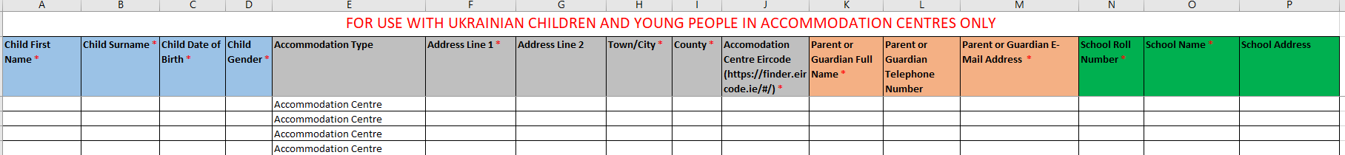

KEY POINTS
- Complete all fields where possible
- Pay particular attention to mandatory fields marked with (*) as if this information is blank then Bus Éireann will be unable to process the form. This will result in the form being returned to you, which will delay the application process.

