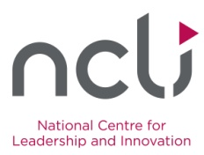
National Centre for Leadership and Innovation
Leadership Award 2014
Nomination Form

Person Nominated

Name:
Address:

School:
School Roll No.:
(If known)
Telephone No.:
Email Address:

Nominated by

Your name:
Your address:

Your title / organisation:
Your Telephone No.:
Email Address:

Reasons for nomination

- Which one of the following criteria does the nominee match?
Primary school pupil
Parent/guardian of a primary school pupil
Member of a Parent Association
Primary school teacher
School ancillary staff
Current or retired primary school principal
Board of Management member

- Please provide a synopsis to support your reasons for nominating this person for this award. (300 word maximum)

- What are the nominee’s most notable achievements as a leader? (250 word maximum)

- How has he/she influenced others? (250 word maximum)

- How did you hear about the NCLI Leadership Awards?
E-scéal
Radio
Newspaper
Leadership+
Networking
Word of mouth
www.ippn.ie
Twitter / Social Media
Other _______________________________

Please submit your completed nomination form by emailing info@ncli.ie or post it to:
NCLI Leadership Award, IPPN Support Office, Glounthaune, Cork

All nominations must be submitted no later than Friday, 5th December 2014.

An independent Adjudication Committee will review all nominations and, based on the criteria, will determine the award recipient. The Award will be presented at IPPN’s Annual Conference on 30th January 2015.

